Michael Colistro

0488092

COMP4475

Assignment 1

For the first 2 questions, I designed them to start by calling the start rule. start.

This following is just me showing Question 1 working and how to use it.

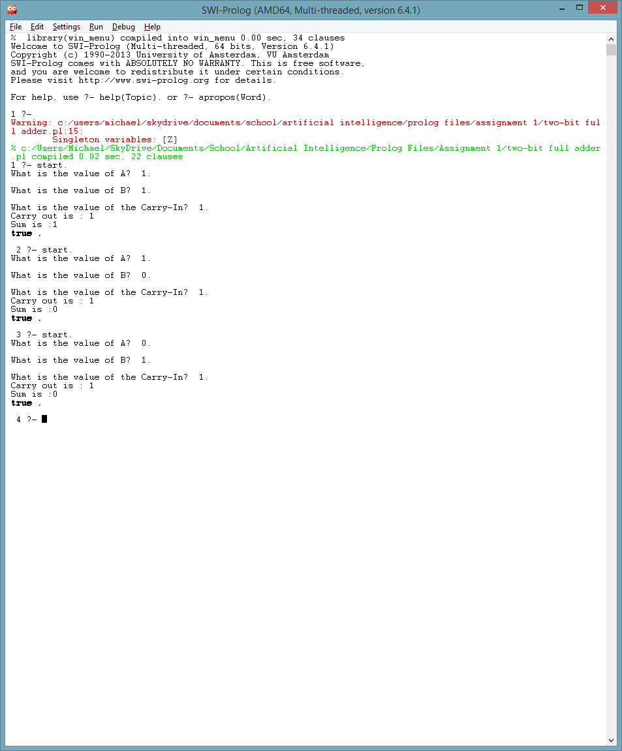

The following is question 2:

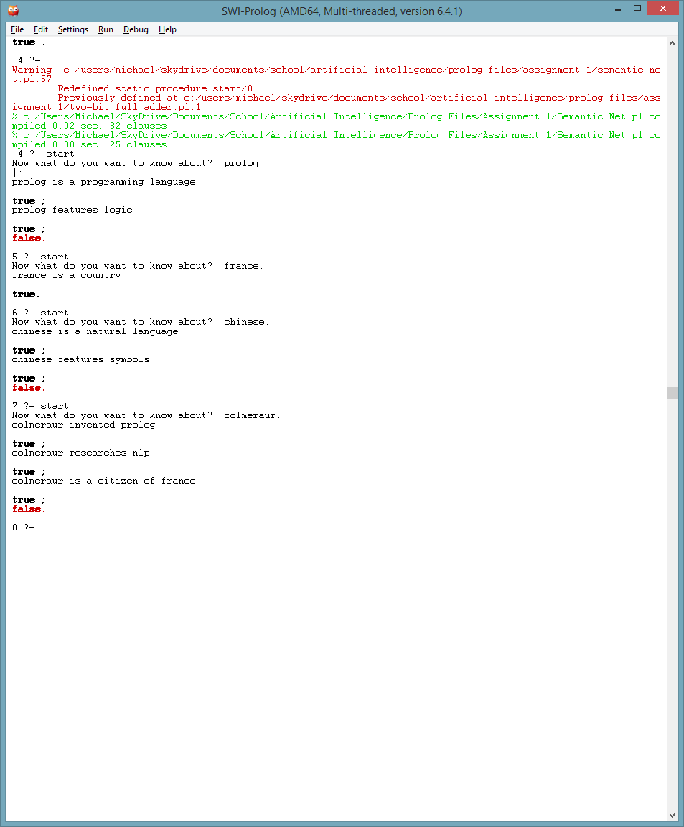

The following is question 3:



The following is question 4, as you can see the names are changeable:

